**// Subroutine : UpdateButtonClick_DESIGN_CUFFS()**

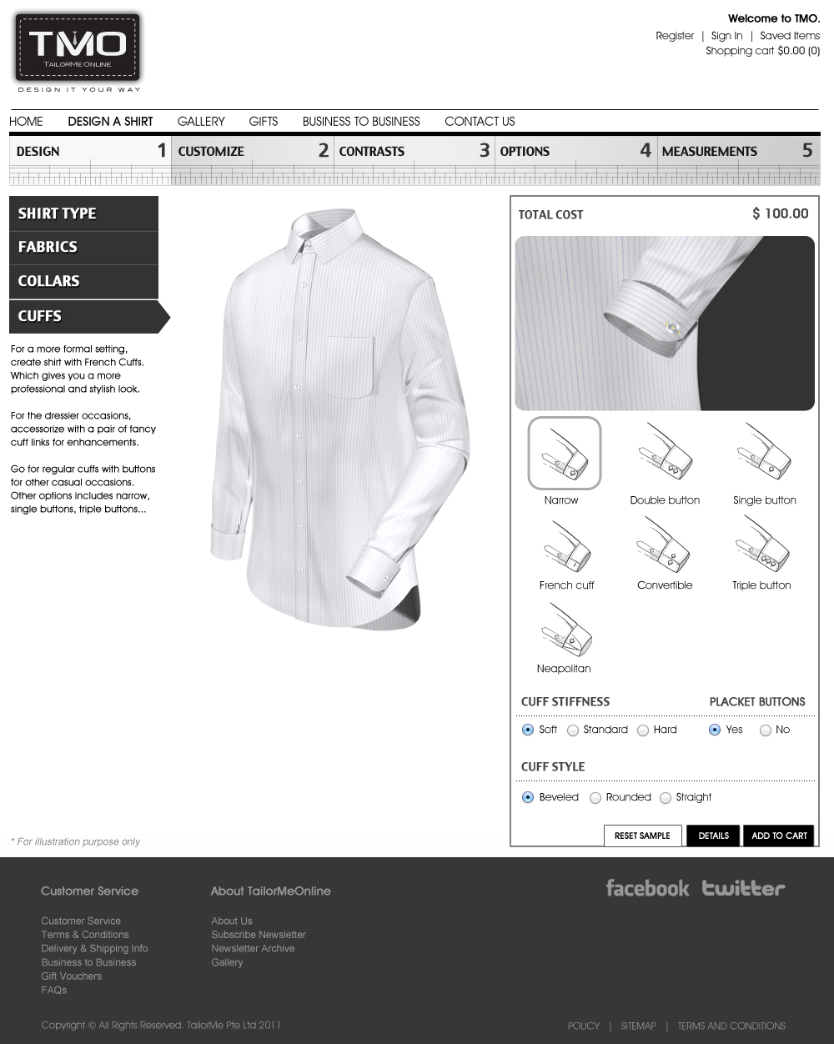

//------------------------------------------------------------------ Cuff

Siva, remove “White tie” and “Fiffig French” from the menu

Upon clicking “Narrow”:

CuffLyr02[3] = “Narrow-Outer.”;

CuffLyr03[3] = “Narrow-Inner.”;

CuffLyr04[3] = “Narrow-Thread.”;

CuffLyr05[3] = “Narrow-Button.”;

ShirtLyr12[3] = “Narrow-Outer.”;

ShirtLyr13[3] = “Narrow-Inner.”;

ShirtLyr14[3] = “Narrow-Thread.”;

ShirtLyr15[3] = “Narrow-Button.”;

ShirtLyr16[2] = “Cuff-ShortRight.”;

If (CuffLyr02[2] == “Neapolitan”)

CuffLyr02[2] = “Str”;

CuffLyr03[2] = “Str”;

CuffLyr04[2] = “Str”;

CuffLyr05[2] = “Str”;

ShirtLyr12[2] = “Cuff-Str”;

ShirtLyr13[2] = “Cuff-Str”;

ShirtLyr14[2] = “Cuff-Str”;

ShirtLyr15[2] = “Cuff-Str”;

Set the toggle button at CUFF STYLE to “Straight”

Call Subroutine : RefreshFilenames();

Call Subroutine : DisplayCuff(); // This updates the cuff window

Call Subroutine : DisplayFullview(); // This updates the full shirt window

Upon clicking “Double button”:

CuffLyr02[3] = “DbButton-Outer.”;

CuffLyr03[3] = “DbButton-Inner.”;

CuffLyr04[3] = “DbButton-Thread.”;

CuffLyr05[3] = “DbButton-Button.”;

ShirtLyr12[3] = “DbButton-Outer.”;

ShirtLyr13[3] = “DbButton-Inner.”;

ShirtLyr14[3] = “DbButton-Thread.”;

ShirtLyr15[3] = “DbButton-Button.”;

ShirtLyr16[2] = “Cuff-NormRight.”;

If (CuffLyr02[2] == “Neapolitan”)

CuffLyr02[2] = “Str”;

CuffLyr03[2] = “Str”;

CuffLyr04[2] = “Str”;

CuffLyr05[2] = “Str”;

ShirtLyr12[2] = “Cuff-Str”;

ShirtLyr13[2] = “Cuff-Str”;

ShirtLyr14[2] = “Cuff-Str”;

ShirtLyr15[2] = “Cuff-Str”;

Set the toggle button at CUFF STYLE to “Straight”

Call Subroutine : RefreshFilenames();

Call Subroutine : DisplayCuff(); // This updates the cuff window

Call Subroutine : DisplayFullview(); // This updates the full shirt window

Upon clicking “Double button”:

CuffLyr02[3] = “DbButton-Outer.”;

CuffLyr03[3] = “DbButton-Inner.”;

CuffLyr04[3] = “DbButton-Thread.”;

CuffLyr05[3] = “DbButton-Button.”;

ShirtLyr12[3] = “DbButton-Outer.”;

ShirtLyr13[3] = “DbButton-Inner.”;

ShirtLyr14[3] = “DbButton-Thread.”;

ShirtLyr15[3] = “DbButton-Button.”;

ShirtLyr16[2] = “Cuff-NormRight.”;

If (CuffLyr02[2] == “Neapolitan”)

CuffLyr02[2] = “Str”;

CuffLyr03[2] = “Str”;

CuffLyr04[2] = “Str”;

CuffLyr05[2] = “Str”;

ShirtLyr12[2] = “Cuff-Str”;

ShirtLyr13[2] = “Cuff-Str”;

ShirtLyr14[2] = “Cuff-Str”;

ShirtLyr15[2] = “Cuff-Str”;

Set the toggle button at CUFF STYLE to “Straight”

Call Subroutine : RefreshFilenames();

Call Subroutine : DisplayCuff(); // This updates the cuff window

Call Subroutine : DisplayFullview(); // This updates the full shirt window

Upon clicking “Single button”:

CuffLyr02[3] = “SingleButton-Outer.”;

CuffLyr03[3] = “SingleButton-Inner.”;

CuffLyr04[3] = “SingleButton-Thread.”;

CuffLyr05[3] = “SingleButton-Button.”;

ShirtLyr12[3] = “SingleButton-Outer.”;

ShirtLyr13[3] = “SingleButton-Inner.”;

ShirtLyr14[3] = “SingleButton-Thread.”;

ShirtLyr15[3] = “SingleButton-Button.”;

ShirtLyr16[2] = “Cuff-NormRight.”;

If (CuffLyr02[2] == “Neapolitan”)

CuffLyr02[2] = “Str”;

CuffLyr03[2] = “Str”;

CuffLyr04[2] = “Str”;

CuffLyr05[2] = “Str”;

ShirtLyr12[2] = “Cuff-Str”;

ShirtLyr13[2] = “Cuff-Str”;

ShirtLyr14[2] = “Cuff-Str”;

ShirtLyr15[2] = “Cuff-Str”;

Set the toggle button at CUFF STYLE to “Straight”

Call Subroutine : RefreshFilenames();

Call Subroutine : DisplayCuff(); // This updates the cuff window

Call Subroutine : DisplayFullview(); // This updates the full shirt window

Upon clicking “Neapolitan”:

CuffLyr02[2] = “Neapolitan”;

CuffLyr03[2] = “Neapolitan”;

CuffLyr04[2] = “Neapolitan”;

CuffLyr05[2] = “Neapolitan”;

ShirtLyr12[2] = “Cuff-Neapolitan”;

ShirtLyr13[2] = “Cuff-Neapolitan”;

ShirtLyr14[2] = “Cuff-Neapolitan”;

ShirtLyr15[2] = “Cuff-Neapolitan”;

CuffLyr02[3] = “-Outer.”;

CuffLyr03[3] = “-Inner.”;

CuffLyr04[3] = “-Thread.”;

CuffLyr05[3] = “-Button.”;

ShirtLyr12[3] = “-Outer.”;

ShirtLyr13[3] = “-Inner.”;

ShirtLyr14[3] = “-Thread.”;

ShirtLyr15[3] = “-Button.”;

ShirtLyr16[2] = “Cuff-NormRight.”;

Set the toggle button at CUFF STYLE to “Straight”

Call Subroutine : RefreshFilenames();

Call Subroutine : DisplayCuff(); // This updates the cuff window

Call Subroutine : DisplayFullview(); // This updates the full shirt window

Upon clicking “French”: // Siva, please change the icon name to “French” instead of “French cuff”

CuffLyr02[3] = “French-Outer.”;

CuffLyr03[3] = “French-Inner.”;

CuffLyr04[3] = “French-Thread.”;

CuffLyr05[3] = “French-Button.”;

ShirtLyr12[3] = “French-Outer.”;

ShirtLyr13[3] = “French-Inner.”;

ShirtLyr14[3] = “French-Thread.”;

ShirtLyr15[3] = “French-Button.”;

ShirtLyr16[2] = “Cuff-NormRight.”;

If (CuffLyr02[2] == “Neapolitan”)

CuffLyr02[2] = “Str”;

CuffLyr03[2] = “Str”;

CuffLyr04[2] = “Str”;

CuffLyr05[2] = “Str”;

ShirtLyr12[2] = “Cuff-Str”;

ShirtLyr13[2] = “Cuff-Str”;

ShirtLyr14[2] = “Cuff-Str”;

ShirtLyr15[2] = “Cuff-Str”;

Set the toggle button at CUFF STYLE to “Straight”

Call Subroutine : RefreshFilenames();

Call Subroutine : DisplayCuff(); // This updates the cuff window

Call Subroutine : DisplayFullview(); // This updates the full shirt window

Upon clicking “Convertible”:

CuffLyr02[3] = “Convertible-Outer.”;

CuffLyr03[3] = “Convertible-Inner.”;

CuffLyr04[3] = “Convertible-Thread.”;

CuffLyr05[3] = “Convertible-Button.”;

ShirtLyr12[3] = “Convertible-Outer.”;

ShirtLyr13[3] = “Convertible-Inner.”;

ShirtLyr14[3] = “Convertible-Thread.”;

ShirtLyr15[3] = “Convertible-Button.”;

ShirtLyr16[2] = “Cuff-NormRight.”;

If (CuffLyr02[2] == “Neapolitan”)

CuffLyr02[2] = “Str”;

CuffLyr03[2] = “Str”;

CuffLyr04[2] = “Str”;

CuffLyr05[2] = “Str”;

ShirtLyr12[2] = “Cuff-Str”;

ShirtLyr13[2] = “Cuff-Str”;

ShirtLyr14[2] = “Cuff-Str”;

ShirtLyr15[2] = “Cuff-Str”;

Set the toggle button at CUFF STYLE to “Straight”

Call Subroutine : RefreshFilenames();

Call Subroutine : DisplayCuff(); // This updates the cuff window

Call Subroutine : DisplayFullview(); // This updates the full shirt window

Upon clicking “Triple button”:

CuffLyr02[3] = “TrpButton-Outer.”;

CuffLyr03[3] = “TrpButton-Inner.”;

CuffLyr04[3] = “TrpButton-Thread.”;

CuffLyr05[3] = “TrpButton-Button.”;

ShirtLyr12[3] = “TrpButton-Outer.”;

ShirtLyr13[3] = “TrpButton-Inner.”;

ShirtLyr14[3] = “TrpButton-Thread.”;

ShirtLyr15[3] = “TrpButton-Button.”;

ShirtLyr16[2] = “Cuff-HighRight.”;

If (CuffLyr02[2] == “Neapolitan”)

CuffLyr02[2] = “Str”;

CuffLyr03[2] = “Str”;

CuffLyr04[2] = “Str”;

CuffLyr05[2] = “Str”;

ShirtLyr12[2] = “Cuff-Str”;

ShirtLyr13[2] = “Cuff-Str”;

ShirtLyr14[2] = “Cuff-Str”;

ShirtLyr15[2] = “Cuff-Str”;

Set the toggle button at CUFF STYLE to “Straight”

Call Subroutine : RefreshFilenames();

Call Subroutine : DisplayCuff(); // This updates the cuff window

Call Subroutine : DisplayFullview(); // This updates the full shirt window

//------------------------------------------------------------------ Cuff Stiffness

This has no effect on the display

//------------------------------------------------------------------ Placket Buttons

This has no effect on the display (fyi, this is referring to the placket on the sleeve, which is hidden, not the body placket)

//------------------------------------------------------------------ Cuff Style

Upon clicking “Beveled”:

If (CuffLyr02[2] != “Neapolitan”)

CuffLyr02[2] = “Bev”;

CuffLyr03[2] = “Bev”;

CuffLyr04[2] = “Bev”;

CuffLyr05[2] = “Bev”;

ShirtLyr12[2] = “Cuff-Bev”;

ShirtLyr13[2] = “Cuff-Bev”;

ShirtLyr14[2] = “Cuff-Bev”;

ShirtLyr15[2] = “Cuff-Bev”;

Else

Set the toggle button at CUFF STYLE to “Straight”

Call Subroutine : RefreshFilenames();

Call Subroutine : DisplayCuff(); // This updates the cuff window

Call Subroutine : DisplayFullview(); // This updates the full shirt window

Upon clicking “Rounded”:

If (CuffLyr02[2] != “Neapolitan”)

CuffLyr02[2] = “Rd”;

CuffLyr03[2] = “Rd”;

CuffLyr04[2] = “Rd”;

CuffLyr05[2] = “Rd”;

ShirtLyr12[2] = “Cuff-Rd”;

ShirtLyr13[2] = “Cuff-Rd”;

ShirtLyr14[2] = “Cuff-Rd”;

ShirtLyr15[2] = “Cuff-Rd”;

Else

Set the toggle button at CUFF STYLE to “Straight”

Call Subroutine : RefreshFilenames();

Call Subroutine : DisplayCuff(); // This updates the cuff window

Call Subroutine : DisplayFullview(); // This updates the full shirt window

Upon clicking “Straight”:

If (CuffLyr02[2] != “Neapolitan”)

CuffLyr02[2] = “Str”;

CuffLyr03[2] = “Str”;

CuffLyr04[2] = “Str”;

CuffLyr05[2] = “Str”;

ShirtLyr12[2] = “Cuff-Str”;

ShirtLyr13[2] = “Cuff-Str”;

ShirtLyr14[2] = “Cuff-Str”;

ShirtLyr15[2] = “Cuff-Str”;

Call Subroutine : RefreshFilenames();

Call Subroutine : DisplayCuff(); // This updates the cuff window

Call Subroutine : DisplayFullview(); // This updates the full shirt window

**// End of Subroutine : UpdateButtonClick_DESIGN_CUFFS()**